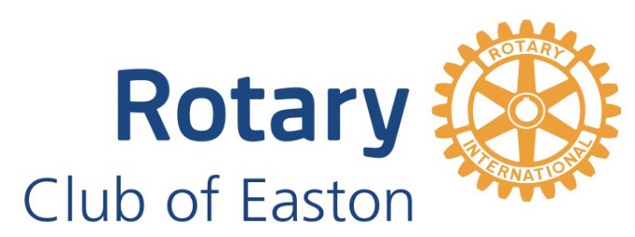

29th ANNUAL JACK BENNETT HOLIDAY CLASSIC BASKETBALL TOURNAMENT

December 29 - 30, 2025

PROGRAM SPONSORSHIP FORM – 2025

Friends of Easton Rotary - Digital Program Sponsors

Place on ‘X’ on the desired sponsor level:

- Full Page digital program ad: $500

- Half Page digital program ad: $300

- Quarter Page digital program ad: $200

- Business Card in digital program: $100
Size: Standard Business Card – 8 to a page

Ad Submission - PLEASE NOTE:
- All ads must be submitted in one of the following formats: gif, tiff, jpg, or bmp formats.
- All ads are in color.
- Full page ads can be submitted as pdf files.
- Your business card can be submitted to scan for your business card ad.

Email Ad to: lewisfish22@gmail.com
Subject: Easton Rotary JBHC Ad

Please provide the following information when returning your sponsor form and check:
- Sponsor Name (As it will appear on all advertising):
- Sponsorship level and amount of enclosed check:
- Contact Person: ___________________
- Contact Telephone: ________________
- Contact Email: ____________________
- Contact Mailing Address:

Please make your check payable to the ‘Rotary Club of Easton’ if your sponsorship is an advertising expense or payable to the ‘Easton Rotary Service Foundation’ if your sponsorship is a charitable deduction.

Please mail both pages of this form with your check to:

Lew Fish, Tournament Co-Chairman
1526 Hedgerow Court
Easton, PA 18040

Office: 610-597-5852

Deadline for Sponsorships Returns: December 10, 2025

If you need additional information, or have any questions, please contact the
Tournament Co-Chairs:
Lew Fish
610-597-5852
lewisfish22@gmail.com
or
Gordon Bigelow
570-579-4167
gbigelow1918@gmail.com

Please put ‘Easton Rotary JBHC’ as the subject of the email.

THANK YOU!
ROTARY CLUB OF EASTON, PA.

